# Tale of Non-Clickable Link in SMS

Gone are the days when we used to receive a tracking link sent via SMS while ordering food from the leading brands (also our customers) which was not clickable. The tracking link provides visibility to end users about their ordered food. To send an SMS via SMS Gateway, you send the SMS body as a plain string in the request data, and the mobile app receiving SMS is accountable to make the tracking link clickable for the end users.

The reason behind this finding done by our Dev team was to check that how many devices got affected with this SMS bug. Whenever the SMS was forwarded to individuals who were waiting eagerly for their ordered food, almost 30% of the individuals couldn’t see the clickable link while viewing the SMS. It had been observed that individuals who couldn’t see the clickable link in SMS could receive and see several other SMSs included with the clickable links. Earlier we used to work with Firebase service to create short links e.g. [https://*.page.link/xxx](https://*.page.link/xxx), but upon finding that the end users are facing issues, we immediately started brainstorming its solution.

A company which sends SMS is not accountable for SMS rendering. Instead, our work was to understand that how does it render some links correctly, and others not.

After a close inspection of the SMS body in which the link was shared, we compared it with the SMS sent by FarEye team and found that the difference in link was the root cause of this concern. So, we immediately modified the text of SMS from [https://*.page.link/xxx](https://*.page.link/xxx) to [https://*.page.net/xxx](https://*.page.net/xxx). Now, every end user who was facing this issue could see and access the clickable link shared via SMS. In another words, the mobile apps facing such issue had a bug while rendering SMS text with a clickable link.

If you dig into the history of how TLDs came into the picture, you will understand that it originally started with .com, .net, and a few other TLDs but a new TLD recently came into existence after the ICANN’s approval. There might be a reason why this issue remained unresolved because app developers and testing teams checked the rendering of .com and .net domains but ignored the newly introduced TLD. Hence, they didn’t update the existing logic of rendering clickable links.

Following is the [stat](https://domainnamestat.com/statistics/tldtype/generic)istics of renowned domains registered so far on .com/ .net and also comparing them with other generic TLDs such as .link, etc.

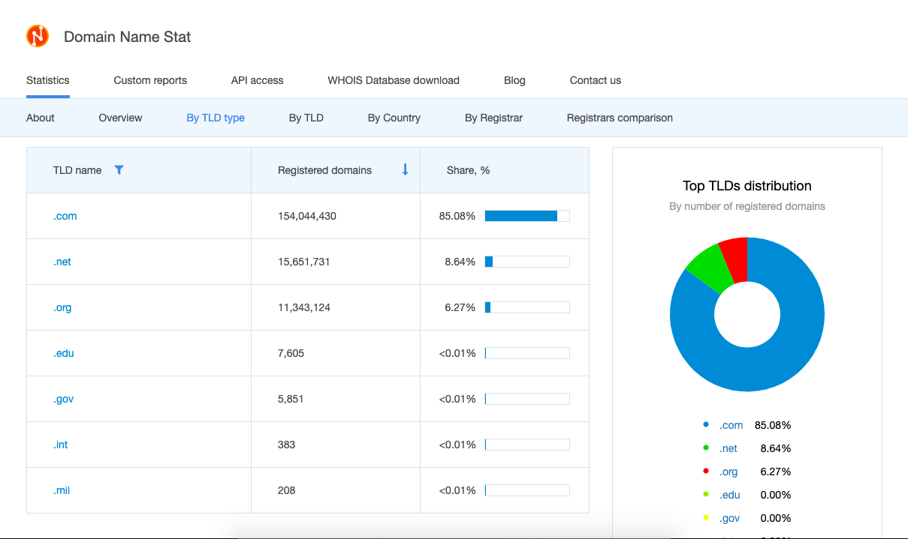

Here is the next set of actions that we followed:

* Purchasing a domain name with TLD, such as .com or .net. We purchased trckin.net which is used for the tracking activity.
* Configuring the purchased custom domain on Firebase.
* Passing a new domain in the Firebase API calls for shortening the URL.

After implementing the steps listed above, we observed that how the issue got resolved.

[caption id="attachment_114" align="aligncenter" width="281"]

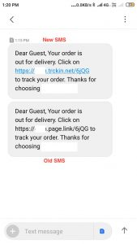

The above screenshot contains two SMS, one with a clickable link and another with a non-clickable link [/caption].

However, we have resolved the issue for ourselves using TLDs, but others might still be experiencing the same issue if they haven’t migrated their domains to TLDs yet. It is advisable to get this issue fixed at its root when the default/custom SMS app is installed in the mobile device. This is being done to ensure that we can use the latest TLDs without any hassle.